Are you looking for something more impactful in the New Decade?
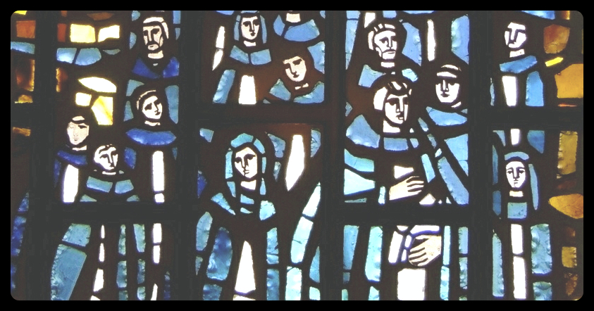
Dominican Family Informational Gathering
Please join us for wine and snacks…
You are invited to join the Dominican Family on Wednesday evening, January 15, 2020 at the Dominican Sisters Conference Center at 6501 Almeda Road at 6:30 PM for wine and snacks followed by a short presentation on Saint Dominic by Sr. Carol Mayes, O.P. You will also hear about the formation of the Dominican Family, and its mission as we walk side-by-side with the Dominican Sisters of Houston. We will finish by 8:00 PM.
In eleven years, the Dominican Family has grown to over 160 women and men who are committed to promoting the principles of Saint Dominic through prayer, study, community and ministry.
Come see what the excitement is all about, and how you can get involved.
Please RSVP by January 12th to Liz Witrago at ewitrago@domhou.org or call 713-440-3710

